To: | Cabinet
Date: | 14 December 2022
Report of: | Acting Head of Planning Services (Planning Policy)
Title of Report: | Authority Monitoring Report and Infrastructure Funding Statement 2021/22

Summary and recommendations
Purpose of report: |  | To seek approval of the Authority Monitoring Report and Infrastructure Funding Statement for publication.
Key decision: |  | No
Cabinet Member: |  | Councillor Alex Hollingsworth, Cabinet Member for Planning and Housing Delivery
Corporate Priority: |  | Enable an inclusive economy  Deliver more affordable housing  Support thriving communities  Pursue a zero carbon Oxford
Policy Framework: |  | The Authority Monitoring Report is a statutory requirement, providing information as to the extent to which the policies set out in the Oxford Local Plan are being achieved and on the implementation of the Local Development Scheme. The scope of those policies is wide, and encompasses all of the Council’s corporate priorities.  The Infrastructure Funding Statement is a factual report and statutory requirement which summarises the amount of developer contributions (CIL and Section 106) obtained, allocated and spent by the authority in the previous financial year (April 2021 – March 2022).
Recommendations: That Cabinet resolves to:
1. | Approve the Authority Monitoring Report and Infrastructure Funding Statement 2021/22 for publication; and
2. | Authorise the Acting Head of Planning Services (Planning Policy) to make any necessary minor, non-material corrections to the document prior to publication.

Appendices
Appendix 1 | Authority Monitoring Report 2021/22
Appendix 2 | Infrastructure Funding Statement 2021/22
Appendix 3 | Risk Assessment
Appendix 4 | Equalities Impact Assessment

Introduction and background
- Section 35 of the Planning and Compulsory Purchase Act 2004 requires local planning authorities to publish monitoring reports at least yearly in the interests of transparency.
The Authority Monitoring Report (AMR) 2021/22 assesses the effectiveness of planning policies contained within the Oxford Local Plan (OLP) 2036 as well as the implementation of the Oxford Local Development Scheme 2022-2027, the Council’s Statement of Community Involvement in Planning and the Duty to Cooperate. The AMR covers the period 1st April 2021 to 31st March 2022 and is a factual document.
The AMR is structured as follows: a status report on the production of development plan documents, followed by the monitoring of the Oxford Local Plan 2036 policies. Policy monitoring has been arranged around the three overarching objectives set out in paragraph 8 of the National Planning Policy Framework (NPPF) 2021:
- Economic objectives to build a strong, responsive and competitive economy - the economy, retail, community and infrastructure;
- Social objectives to support building strong, vibrant and healthy communities – housing, health and community benefits; and
- Environmental objectives to project and enhance our natural, built and historic environment – design and heritage, protecting our green and blue spaces and making wise use of our natural resources to secure a good quality local environment.
The Infrastructure Funding Statement (IFS) is a reporting requirement introduced as part of the Community Infrastructure Levy (Amendment) (England) (No.2) Regulations in September 2019 (CIL Regulations: Schedule 2), with the objective of increasing transparency around how developer contributions are spent on infrastructure. As set out in Appendix 2, the contents of the IFS are divided into three key sections for the previous financial year:
- Information on Community Infrastructure Levy (CIL) contributions;
- Information on Section 106 contributions (made under section 106 of the Town and Country Planning Act 1990);
- Items of infrastructure that CIL is to be spent on in the next five years (CIL is allocated to the Council’s Capital Programme as part of the Budget setting process).
The Oxford Local Plan was adopted in June 2020. During the monitoring year the Wolvercote Neighbourhood Plan was adopted.

Key AMR findings: Building a strong, responsive and competitive economy

Employment land
Oxford’s highly constrained nature means that competition for different land uses is fierce. As such Policy E1: Employment Sites sets out how employment sites are categorised in order of importance and thus afforded different levels of protection. Category 1 & 2 employment sites are key in providing employment space for the city, whereas Category 3 sites and B8 sites provide more potential to be released from employment uses to ensure the best and most efficient use of land.
- Permissions granted resulting in the net loss of Category 1 & 2 employment floorspace: none;
- Total loss of Category 3 employment floorspace: 1,943m²;
- Total gain of employment floorspace: 88,370m²;
- Applications for changes of use from office to residential which are subject to notification to the council: 4 granted and 2 refused.

Growth of Oxford’s universities
The City Council is committed to supporting the sustainable growth of the two universities within the parameters of competing demands for land. The universities are encouraged to focus growth on their own sites by making the best use of their current landholdings as well as the redevelopment and intensification of their assets where appropriate. Policy E2: Teaching and Research states that new or additional academic floorspace will only be granted if it is demonstrated that additional student accommodation is not required or is provided as set out in Policy H9: Linking the delivery of new/redeveloped and refurbished university academic facilities to the delivery of university provided residential accommodation.
The University of Oxford had 26,439 students attending the University and its colleges at 1 December 2021; of these 11,566 were excluded from accommodation needs as they were not on full time taught courses leaving 14,873 full-time students with accommodation needs. At 1 December there were 13,382 accommodation places provided, leaving a total of 1,491 students living outside of university accommodation which is within the threshold (2,500) set out in policy H9 for the University of Oxford. This figure represents a significant increase when compared to the previous monitoring period (2020/21 - 1,009) and is attributable to the exceptional variations in student numbers which the University has explained is because of the fallout from an unprecedented over-recruitment of students in the previous year due to the impact of Covid-19 and the government’s changes to A-Level grading, as well as graduate market uncertainty. Once this cohort works through the system, the numbers of students are expected to decline.
- Oxford Brookes University (OBU) had 16,199 students attending the university at 1 December 2021 of these 8,405 were excluded from accommodation needs leaving 7,794 full-time Oxford Brookes students requiring accommodation. At 1 December 2021 there were 5,161 student places provided leaving 2,633 students without a place in university provided accommodation living in Oxford. This falls below the threshold set out in policy H9 for Oxford Brookes (4,000). This figure also represents a further decline in line with the downward trends compared to previous monitoring periods (2019/20 – 3,845; 2020/21 - 2,873).
- Approved additional academic and administrative floorspace: 1,911m²;
- Number of University of Oxford students living outside of provided accommodation: 1,491 – within policy H9 threshold;
- Number of Oxford Brookes students living outside of provided accommodation: 2,633 – within policy H9 threshold.

Ensuring the vitality of our centres
Oxford provides a wide range of services and facilities to both residents and visitors alike as such, policies have been drafted in the OLP 2036 to maintain and enhance the city’s vibrancy and vitality. Policy V1 aims to protect the town, district and local centres whilst Policies V2-V4 provide the framework as to what mix of uses would be acceptable. These policies placed a particular emphasis on the minimum proportion of Class A1 retail units at ground floor level that should be present within each shopping frontage in order to ensure that the function, vitality and viability of each centre is maintained.
- In September 2020 the Government introduced a series of changes to the use classes system which had implications for recently adopted retail frontage policies V2-V4 as it resulted in less protection for their primary retail function. Classes A & D from the Use Classes Order (UCO) have been revoked with the consequence that the current retail policies in the Plan which monitor the proportion of A1 and other A uses in the designated frontages became obsolete. This is the first AMR that analyses data based on these changes.

Sustainable tourism and cultural venues, community facilities and infrastructure
Tourism is an important and substantial element of Oxford’s economy. The provision of short stay accommodation allows more options for tourists to stay over in the city and thus bring more money into the local economy. Policy V5: Sustainable Tourism seeks to locate new tourist accommodation in accessible locations in order to reduce dependency on the private car, in addition the policy does not permit new accommodation if it would result in the loss of residential dwellings. New tourist attractions in the city must be easily accessible by active travel or public transport and be well related to existing tourist and leisure facilities. Policies V6 and V7 seek to protect cultural, social and community facilities.
- Planning permission granted for additional hotel bedrooms: 251, of which 180 are being delivered at Oxford North.

Key AMR findings: Building strong, vibrant and healthy communities

Housing
In this monitoring year 581 (net) dwellings were completed in Oxford of which 293 were affordable dwellings. The cumulative number of dwellings completed in the 5 years since the start of the Local Plan period (2016/17 to 2021/22) is 3,226 dwellings (net). This includes the equivalent numbers calculated through the application of ratios for communal accommodation (student and care completions).
The Local Plan’s housing trajectory had projected that by 2020/21, 2,942 dwellings (net) would have been provided. Figure 2 below shows that the Council is ahead of the projection and is on target to meet the minimum of 10,884 dwellings to 2036 as set out in policy H1.
Figure 1: Local Plan 2036 Completions and Projections
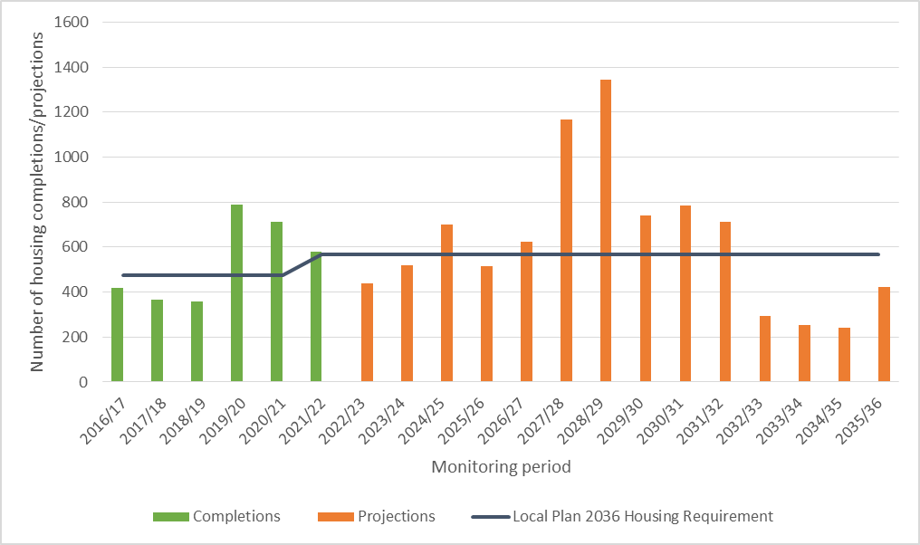
Figure 2: Cumulative Requirement and Cumulative Supply
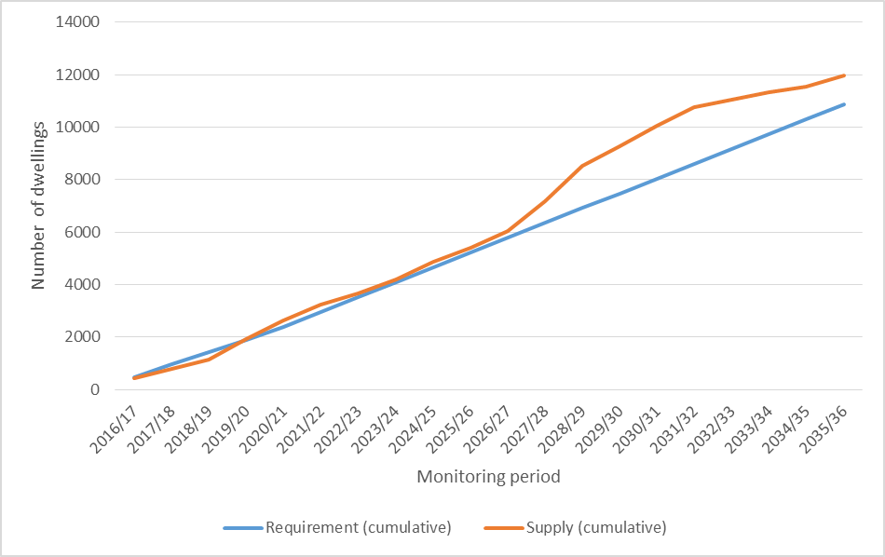
The breakdown of the 293 affordable dwellings completed during the monitoring year is as follows: 25 social rent dwellings on land at St Nicholas Place (17/03050/FUL), 3 social rent dwellings at Garages Rear of 18-34 Mortimer Drive (18/00546/CT3), 84 shared ownership and 4 social rent dwellings at Littlemore Park (18/02303/RES), 1 social rent dwelling at Land Adjacent 27, Broad Oak (18/02113/CT3), 11 social rent, 3 affordable rent and 12 shared ownership dwellings at 15-17 Elsfield Hall (18/03384/FUL), 9 social rent dwellings at Cumberledge House, Cumberledge Close (18/03385/FUL), 14 social rent dwellings at Barton Park Phase 3 (19/00518/FUL), 2 social rent dwellings at 66 Sandy Lane (19/01271/CT3), 1 social rent dwelling at 9 Pauling Road (19/01272/CT3), 19 key worker units at Churchill Hospital (19/01039/FUL), 4 social rent and 3 affordable rent dwellings at The Royal British Legion Club, Edgecombe Road (19/02260/FUL), 38 social rent, 12 affordable rent and 36 shared ownership dwellings at William Morris Sports Ground (20/01086/RES), 8 social rent dwellings at Wolvercote Paper Mill and 4 social rent dwellings at Playground Rear of 22-28 Bracegirdle Road.
Since the start of the Local Plan period there have been a total of 683 affordable homes built (Figure 3).
Figure 3: Net affordable dwellings completed 2016/17 - 2021/22

- The Council is committed to delivering more affordable housing in Oxford and has been identifying land in its ownership capable of delivering affordable homes and bringing this forward wherever possible. Of the 293 affordable dwellings completed in 2021/22, 63 were delivered on City Council Land. The Council has also set up its own housing delivery company, renamed OX Place in 2022, to increase the proportion of affordable housing delivered across the city.
- Net dwellings completed in 2021/22: 581; of which were affordable: 293
- Affordable units delivered on council land in 2021/22: 63,
- Net dwellings permitted in 2021/22: 1,346; of which were affordable: 399.

Provision of new student accommodation
There were 5 planning permissions for student accommodation all of which were compliant with the location criteria set out in Policy H2.
- Applications for new student accommodation: 5.

Housing land supply
The Plan’s annual housing requirement is used to calculate the 5-year housing land supply as set out in the NPPF. The Council has identified a deliverable supply of 2,933 homes which includes the forecast supply from large sites, including those which have been allocated in the Local Plan and outstanding permissions from small sites (commitments) plus a windfall allowance. This gives a housing land supply of 5.47 years. This is lower than the figure reported in last year’s AMR because several allocated sites have not come forward to a planning application as we had anticipated in our previous trajectory. Furthermore, for some allocated sites with planning permission there have been delays in the start of construction which has resulted in anticipated completion dates being pushed back.
At the current time we do not anticipate the land supply to fall further but increase from the 21/22 position. As is shown in Figure 2, over the longer term the forecast supply is always above the requirement, with the gap between the two increasing at a higher rate than at present from year 6 (27/28). We are expecting the Local Plan 2040 Preferred Options consultation to provide further updates on the anticipated delivery of some of the large trajectory sites, alongside a further round of landowner engagement to inform our Housing and Economic Land Availability Assessment (HELAA).
- Housing land supply: 5.47 years.

Key AMR findings: Environmental policies to secure a good quality local environment
There is good conformity with the sustainability related policies set out in the Local Plan which indicates that these policies are working well. The AMR details the performance of these policies and sets out applications that have been refused which do not fully meet targets such as the 40% reduction in carbon emissions, or 5% net gain. This reflects the constrained nature of certain development sites in the city, particularly constraints of heritage status, or simply the profile of brownfield sites.
- Nine major applications were permitted during the monitoring year which met the requirement of a reduction of 40% of regulated energy as required by Policy RE1;
- Nine applications were permitted in Flood Risk areas (2 & 3) are in accordance with Policy RE3;
- Nine major applications were permitted during the monitoring year which met the biodiversity net gain target of 5%;
- Three buildings are on English Heritage’s at-risk register;
- No development permitted that would have a detrimental impact upon green infrastructure corridors or City Wildlife Sites.

Key IFS Headlines:
The IFS reports on the developer contributions received, allocated and spent for 2020-21.
- £1,511,911.45 of CIL was collected in 2021-22 and £1,423,842.98 of CIL was spent towards infrastructure projects. A further £1,825,100.27 of CIL was set out in demand notices in the year for collection;
- Of the £1,423,842.98 spent, £694,977.76 was spent on strategic infrastructure; £10,233.15 was passed to Parish Councils; £643,705.38 was allocated or spent towards Neighbourhood forums and Neighbourhood CIL and £74,926.69 was spent on administration fees;
- In 2021-22, £1,356,435.52 was received in Section 106 agreements and £72,527.14 was spent towards infrastructure projects. A further £1,213,391.08 of S106 agreements were entered into in the year;
- From the total of £13,605,178.28 received under Section 106 planning obligations (but not spent in the year 21-22), contributions are allocated to be spent on primarily affordable housing (£11.951,308.87, 88%); followed by open space/green infrastructure (£1,104,886.65, 8%); Community facilities (£237,000.00, 2%) Highways/transport and travel (£227,029.75, 2%); and Other/Economic development uses (£84,953.01, <1%);
- 262 units of Affordable housing are to be provided from Section 106 agreements entered into in 2021-22.

Carbon and Environmental Considerations
There are no specific carbon and environmental implications arising from this report. Policies in the Local Plan are seeking to optimise opportunities for carbon reduction. This statutory framework brings us closer to our commitment to becoming a Zero Carbon Council by 2030 or earlier and Zero Carbon Oxford by 2040 or earlier.

Financial implications
There are no financial implications arising from these reports. The IFS simply reports on the collection and spending of monies through the Community Infrastructure Levy (CIL) and S106 developer contributions.

Legal issues
The preparation and publication of the AMR (as set out in Appendix A) and the IFS (as set out in Appendix B) are required by the Planning and Compulsory Purchase Act 2004; and Schedule 2 and Regulation 121A of the Community Infrastructure Levy (Amendment) (England) (No.2) Regulations in September 2019.

Level of risk
A risk assessment has been undertaken and the risk register is attached (Appendix 3).

Equalities impact
Please refer to Equalities Impact Assessment (Appendix 4).
Report author | Christian Cameron/ Lan Nguyen
Job title | Data Analyst, Planning Policy  Senior Data Analyst, Planning Policy
Service area or department | Planning Policy, Planning Services
Telephone | 01865 529137/ 252509
e-mail | ccameron@oxford.gov.uk/  lnguyen@oxford.gov.uk

Background Papers: None

https://www.gov.uk/government/publications/national-planning-policy-framework--2

